FIXING THE 264 PROBLEM

This puts the info in 264 \4 into 264 \1 – so you will have 1 or 2 values.

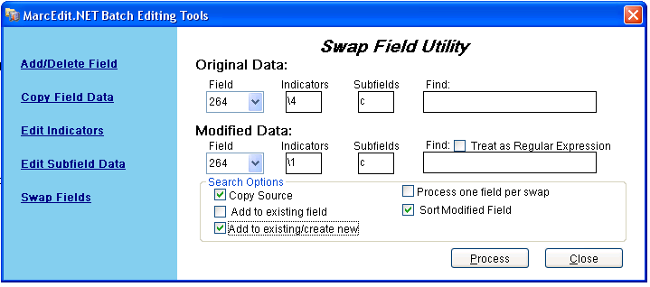

Eliminates a period in subfield b

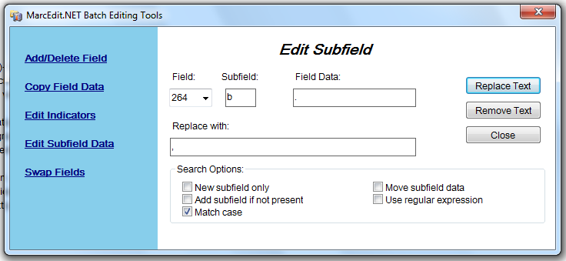

Eliminates 264\4

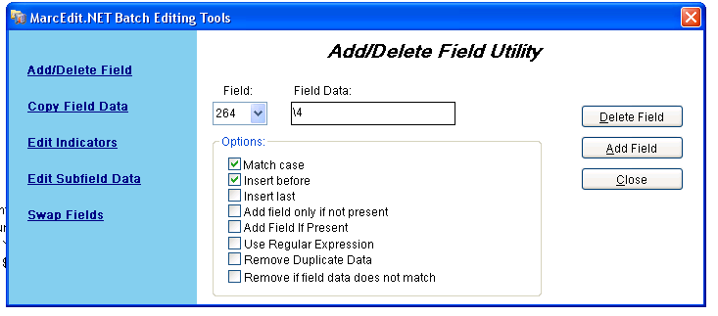

Puts a bracket around copyright dates.

\,\$([c])([c])([0-9])([0-9])([0-9])([0-9])

,$c[$3$4$5$6]

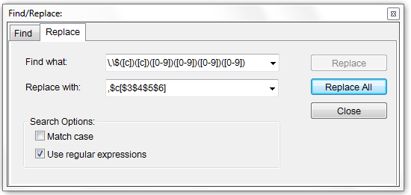

Replaces the double c with c.

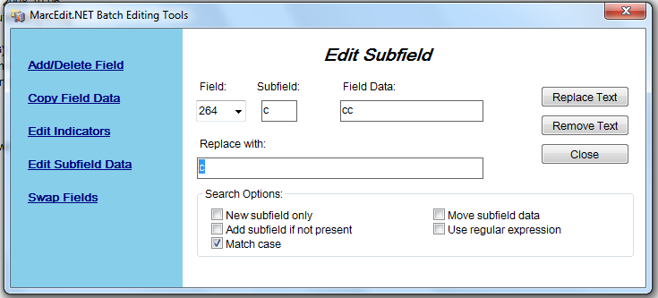

Eliminates the second pub year.

\.\$([c])([0-9])([0-9])([0-9])([0-9])

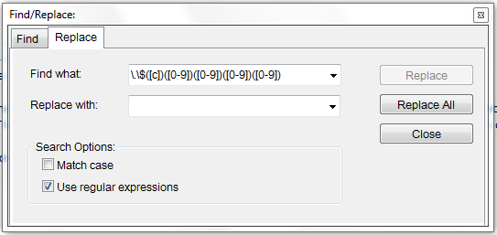

\$([c])\u00A9([0-9])([0-9])([0-9])([0-9]) – with copyright symbol